37.48: a) Using the classical work-energy theorem we obtain
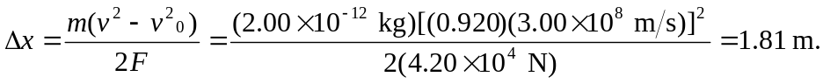
b) Using the relativistic work-energy theorem for a constant force (Eq. 37.35) we obtain
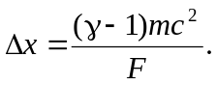
For the given speed, 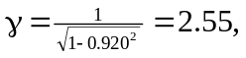 thus
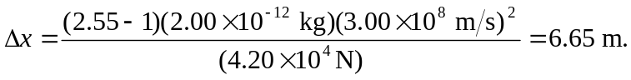
c) According to Eq. 37.30,
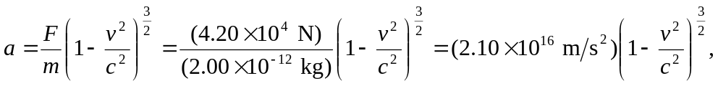
which yields, 